1. Generate draft of Sales Opinion 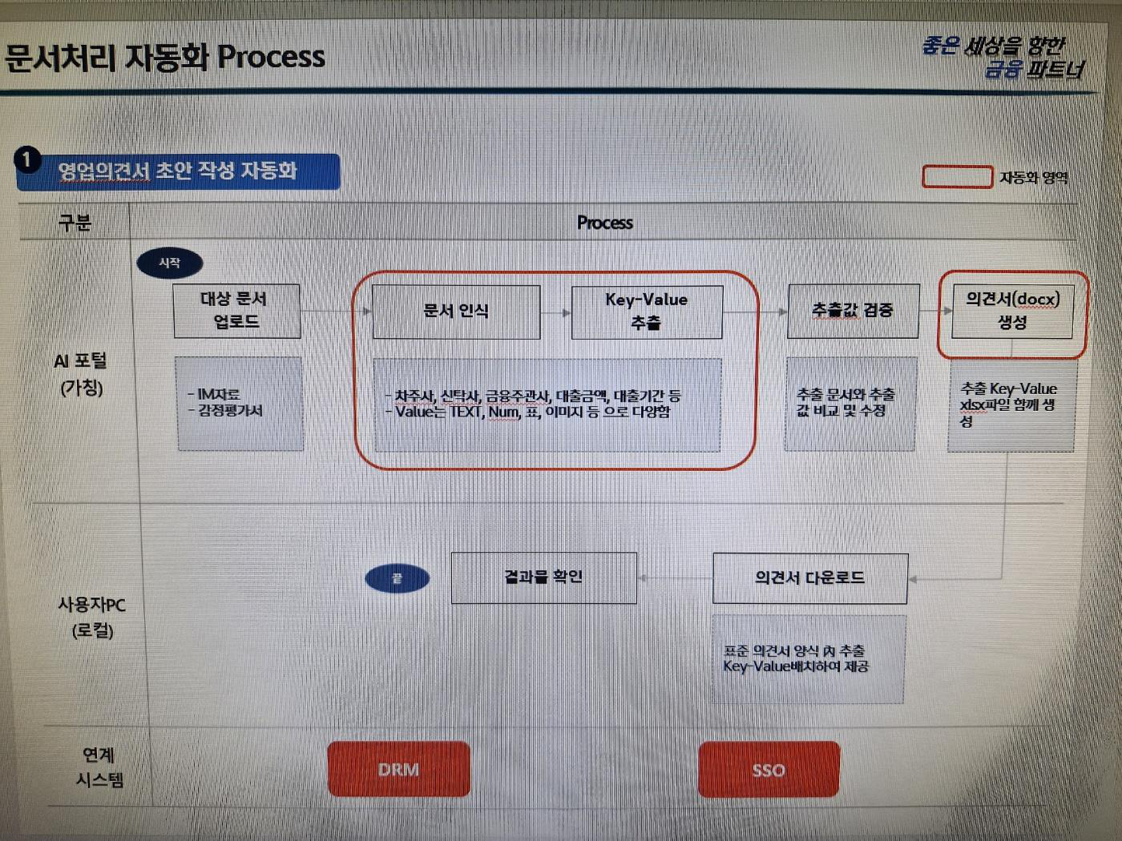

|  |  |  |  |  |
| --- | --- | --- | --- | --- |
| **Upload** | **OCR** | **Extract k-v** | **Verify k-v** | **Generate**  **docx** |
| 2 files: -IM  -valuation doco | Keys will be 신탁사, 차주사, 금융주관사 etc  There will be num, text, table, images | |

|  |  |
| --- | --- |
| **User gets**  **the result** | **Download**  **docx** |

2. Input WINK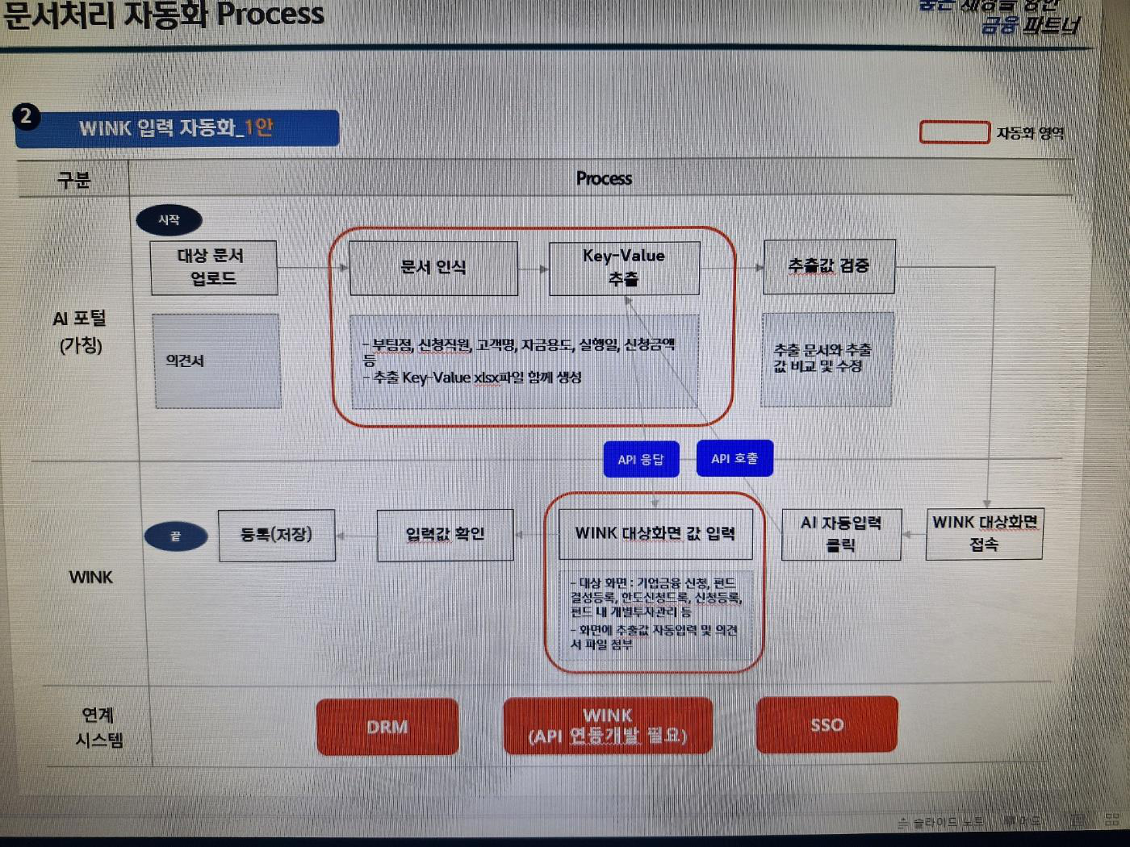

|  |  |  |  |
| --- | --- | --- | --- |
| **Upload** | **OCR** | **K-v** | **Verify** |

**Sales opinion**

Extract it with exel

|  |  |  |  |
| --- | --- | --- | --- |
| **SAVE** | **Verify** | **User clicks** | **User** |
| k-v show in  WINK UI and  sales opinion is  attached |
| **button**  **and API**  **runs** | **Access**  **Wink** |

2. Input WINK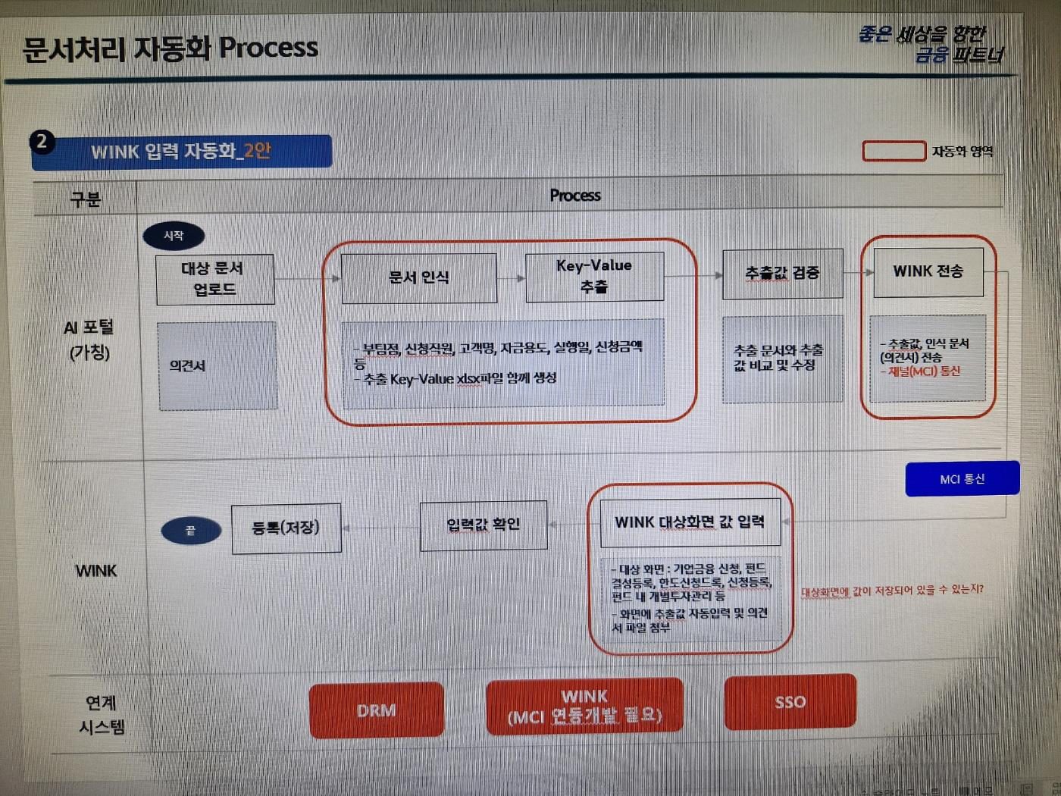

|  |  |  |  |  |
| --- | --- | --- | --- | --- |
| **Upload** | **OCR** | **K-v** | **Verify** | **WINK** |
| **Trnasfer** |

**MCI**

3. Classify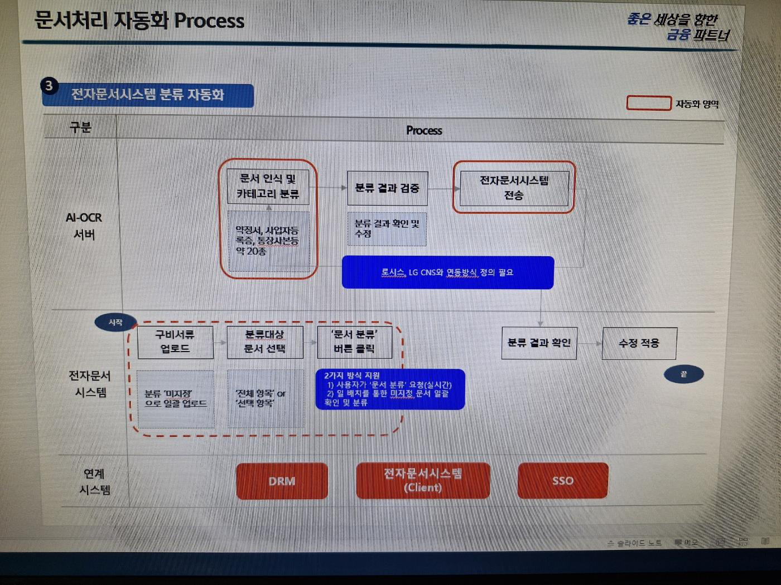

|  |  |
| --- | --- |
| **Verify** | **Send the files to system** |

**OCR and**

**classify 20**

**+. Type**

**files**

|  |  |
| --- | --- |
| Verify | **Save the**  **result** |

4. Generate Fund Report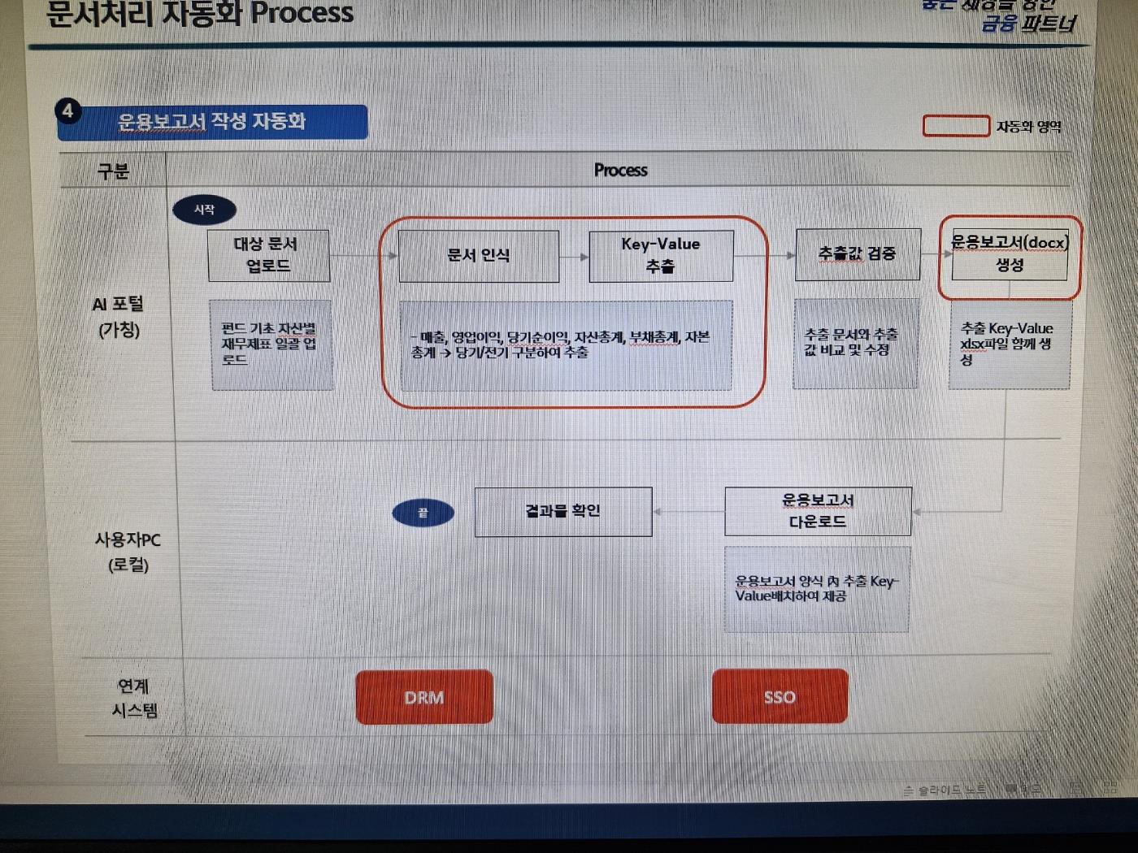

|  |  |  |  |  |  |
| --- | --- | --- | --- | --- | --- |
| **Upload** | **OCR** | **User get the result** | **K-v** | **Verify** | **Generate**  **Docx** |
| Upload all fund  financial  statements | Download | Generat  e with |
| exel |
| sheet |